|  |
| --- |
|  |
| 新概念 3 册 |
| Lesson33 A day to remember |

Book

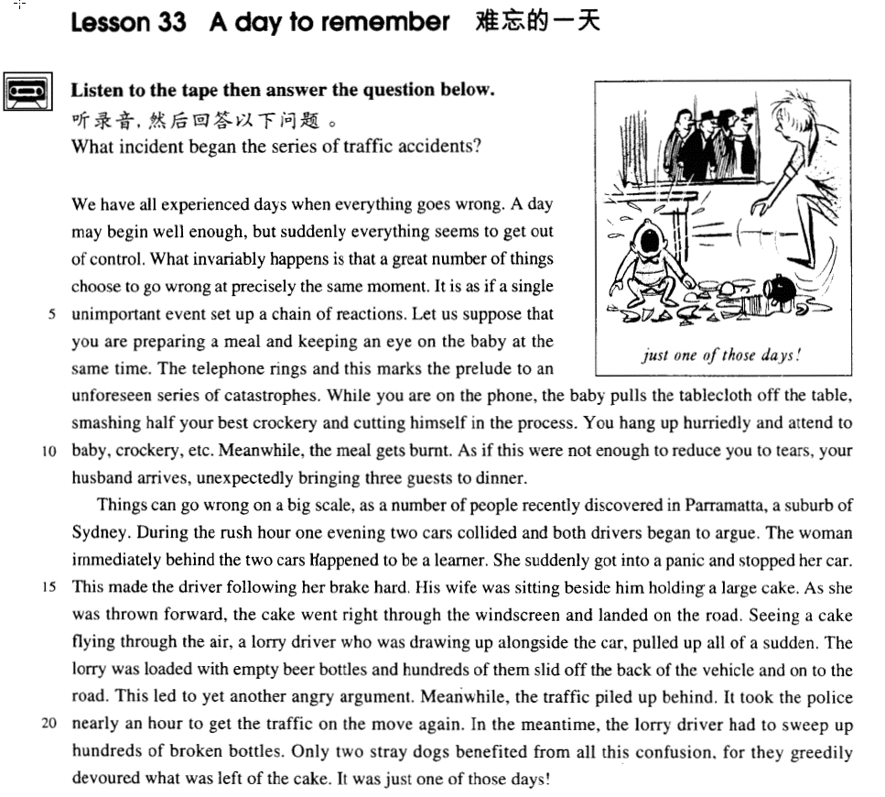

课文

We have all experienced days when everything goes wrong.

我们大家都有过事事不顺心的日子。

A day may begin well enough, but suddenly everything seems to get out of control.

一天开始时，可能还不错，但突然间似乎一切都失去了控制。

What invariably happens is that a great number of things choose to go wrong at precisely the same moment.

情况经常是这样的，许许多多的事情都偏偏赶在同一时刻出问题，

It is as if a single unimportant event set up a chain of reactions.

好像是一件无关紧要的小事引起了一连串的连锁反应。

Let us suppose that you are preparing a meal and keeping an eye on the baby at the same time.

假设你在做饭，同时又在照看孩子。

The telephone rings and this marks the prelude to an unforeseen series of catastrophes.

这时电话铃响了。它预示着一连串意想不到的灾难的来临。

While you are on the phone, the baby pulls the tablecloth off the table, smashing half your best crockery and cutting himself in the process.

就在你接电话时，孩子把桌布从桌子上扯下来，将家中最好的陶瓷餐具半数摔碎，同时也弄伤了他自己。

You hang up hurriedly and attend to baby, crockery, etc.

你急急忙忙挂上电话，赶去照看孩子和餐具。

Meanwhile, the meal gets burnt.

这时，饭又烧糊了。

As if this were not enough to reduce you to tears, your husband arrives, unexpectedly bringing three guests to dinner.

好像这一切还不足以使你急得掉泪，你的丈夫接着回来了，事先没打招呼就带来3个客人吃饭。

Things can go wrong on a big scale as a number of people recently discovered in Parramatta, a suburb of Sydney.

就像许多人最近在悉尼郊区帕拉马塔发现的那样，有时乱子会闹得很大。

During the rush hour one evening two cars collided and both drivers began to argue.

一天傍晚交通最拥挤时，一辆汽车撞上前面一辆汽车，两个司机争吵起来。

The woman immediately behind the two cars happened to be a learner.

紧跟其后的一辆车上的司机碰巧是个初学者，

She suddenly got into a panic and stopped her car.

她一惊之下突然把车停了下来。

This made the driver following her brake hard.

她这一停使得跟在后头的司机也来个急刹车。

His wife was sitting beside him holding a large cake.

司机妻子正坐在他身边，手里托着块大蛋糕。

As she was thrown forward, the cake went right through the windscreen and landed on the road.

她往前一冲，蛋糕从挡风玻璃飞了出去掉到马路上。此时，一辆卡车正好从后边开到那辆汽车边上，

Seeing a cake flying through the air, a lorry driver who was drawing up alongside the car, pulled up all of a sudden.

司机看见一块蛋糕从天而降，紧急刹车。

The lorry was loaded with empty beer bottles and hundreds of them slid off the back of the vehicle and on to the road.

卡车上装着空啤酒瓶。成百只瓶子顺势从卡车后面滑出车外落在马路上。

This led to yet another angry argument.

这又引起一场唇枪舌剑的争吵。

Meanwhile, the traffic piled up behind.

与此同时，后面的车辆排成了长龙，

It took the police nearly an hour to get the traffic on the move again.

警察花了将近一个小时才使车辆又开起来。

In the meantime, the lorry driver had to sweep up hundreds of broken bottles.

在这段时间里，卡车司机不得不清扫那几百只破瓶子。

Only two stray dogs benefited from all this confusion, for they greedily devoured what was left of the cake.

只有两只野狗从这一片混乱中得到好处，它们贪婪地吃掉了剩下的蛋糕。

It was just one of those days!

这就是事事不顺心的那么一天！

词汇讲解

* **prelude** ['prelju:d] n. 序幕，前奏

**prelude (to sth.)** …的前奏

* The high wind is the **prelude to** a heavy storm.

**【相关词汇】**

prologue (to …) 书的序言

preface (to …) 书的序言

foreword (to …) 书的序言

epilogue (to …) 书的后记

* **unforeseen** [ʌnfɔ:'si:n] adj. 意料之外的

**unforeseen**

= **unexpected**

**foresee** ***v.***预料；预见；预知

**expect** ***v.***预料；预期；预计

**foretell** ***v.***（尤指用魔力）预知，预言

**predict** ***v.***预言；预告；预报

* Timely snow foretells a bumper harvest.

forecast ***v./n.***预测；预报

**weather** forecast

* **series** ['sɪəri:z] n. 系列（单复同形）

**species** （单复同形）

* **a series of** books 一套、一些列
* **a series of** stamps 一套、一些列
* **A series of** rainy days spoiled my vacation. 一连串的

**【近义词组】**

表达“一连串的”：

**a chain of …**

**a train of …**

**a trail of …**

**a string of …**

**a stream of …**

* **catastrophe** [kə'tæstrəfɪ] n. 大灾难

【近义词】*不同程度*

**mishap** 小事故

**accident** （交通）事故；意外遭遇；不测事件

**contingency** 可能发生的事；偶发（或不测、意外）事件

**disaster** 灾难；灾祸；灾害

**calamity** (特大)灾难；灾祸

**catastrophe** (特大)灾难；灾祸；横祸

* **crockery** ['krɒkəri] **[U]** n. 陶器

**crockery** **[U]**陶器；瓦器

**pottery** **[U]**陶器（尤指手工制的）

**earthenware** 陶制的

**china** **[U]** 瓷；瓷料; 瓷制品；瓷器

**chinaware** 陶瓷器

**porcelain** **[U**, **C]**瓷；瓷器

* **suburb** ['sʌbɜ:b] n. 郊区

**suburb**

**suburban** 郊区的；城外的；(派生) 平淡乏味的；呆板的

**rural** **[usually before noun]**乡村的；农村的；似农村的

**urban** **[usually before noun]** 城市的；都市的；城镇的

**metropolitan** **[only before noun]**大城市的；大都会的

**cosmopolitan** 世界性的；全球各国的；有各国人的；受各国文化影响的

* **panic** ['pænɪk] n. （突然的）惊慌

**get into a panic** 陷入恐慌

**in a panic**  恐慌的、惊慌失措的

* He fled **in a panic**.
* Don’t **panic** in case of fire. （动词形式）

【形近词】

panic panicked panicking

picnic picnicked picnicking

* **stray [streɪ]** adj. 迷路的，偏离的；v. 迷路，偏离
* a **stray** dog / boy / bullet
* **stray sheep** 迷途的羔羊
* Some of the cattle have **strayed**. （动词形式）
* Don’t **stray** from the point. （动词形式）
* **confusion [kən'fju:ʒən]** n. 混乱；迷惑

**confuse** ***v.***使糊涂；使迷惑；（将 … ）混淆，混同

**confused** ***adj.***糊涂的；迷惑的

**confusing**  ***adj.***难以理解的；不清楚的

【近义词】

**disorder** 杂乱；混乱；凌乱

**in disorder** 处于混乱状态

**mess** 肮脏；杂乱；不整洁

**in a mess** 处于混乱状态

**chaos**  混乱；杂乱；紊乱

**in (a state of) chaos** 处于（…）混乱状态

* All the things I had packed so carefully were soon **in a dreadful mess**.
* Without it, nothing could ever be brought to a conclusion; everything would be **in a state of chaos**.
* **greedily** ['gri:dɪlɪ] adv.贪婪地

**greedy** ***adj.*** 贪婪的；贪心的；贪吃的；渴望的

**gluttonous** ***adj.*** 贪吃的，暴食

* **the seven deadly sins**: 七宗罪
* **greed** 贪婪
* **gluttony** 暴食
* **lust** 色欲
* **envy** 忌妒
* **wrath** 盛怒
* **sloth** 怠惰
* **pride** 骄傲

课文讲解

# （标题）

# A day to remember

**… to remember** 难忘的

* **指环王**
* Gandalf, my old friend … this will be a night **to remember**.

# （第一段）

# We have all experienced days when everything goes wrong.

知识点（1）

**go wrong** 出错，出问题，不顺利

* We have all experienced days when everything **goes wrong**.
* Our marriage began to **go wrong** after we had our first child.
* Something’s **gone wrong** with my computer.
* An advertisement which begins with the magic word FREE can rarely **go wrong**.
* It is all too easy to blame the railway authorities when something doe**s go wrong**.

【课文表达扩展】

We have all experienced days when … （句式）我们都经受过…的日子

* We have all experienced days when **life seems to be a bowl of cherries**（幸福）.
* We have all experienced **moments of misery and despair.**

# A day may begin well enough, but suddenly everything seems to get out of control.

知识点（1）

表达“**突然之间**”：

**suddenly**

**all of a sudden**

**all at once**

* Seeing a cake flying through the air, a lorry driver who was drawing up alongside the car, pulled up **all of a sudden**.
* **All at once**, I noticed that my wife seemed to be filled with alarm.

知识点（2）

**get out of control / hand** 失控

* **托福听力真题：**

A．Discuss the situation with the person in charge of the dormitory.

B．Ask her roommate not to make so much noise.

C．Go to bed after midnight.

D．Send a letter to the residents.

* W: You know the noise in my dorm has really gotten out of control. My roommate and I can rarely get to sleep before midnight.
* M: Why don’t you take the problem up with the dorm supervisor?
* Q: What does the man suggest the woman do?
* Answer: (A) Discuss the situation with the person in charge of the dormitory.
* **6级选择题：**
* We started burning some leaves in our yard, but the fire got*­­* ___A___and we had to call the fire department to put it out.

A．out of hand 失控

B．out of order 出故障

C．out of the question 不可能

D．out of the way 闪开

**get sth. under control** 控制住…

* **听力真题：**

A．The air will be cleaner if they go to a different city.

B．It’ll soon be too late to control the pollution.

C．Society will not pay attention to the new laws.

D．The situation will improve if changes are made.

* M: Look at all the pollution going into the air from those factories. Do you think they’ll ever get that under control?
* W: With the new laws and social awareness, we’ll turn things around.
* Q: What does the woman predict will happen?
* Answer: (D) The situation will improve if changes are made.

# What invariably happens is that a great number of things choose to go wrong at precisely the same moment.

**语法分析：**

What invariably happens（主语从句） is *that a great number of things choose to go wrong（表语从句） at precisely the same moment（时间状语）.*

知识点（1）

**写作句式：**

**what invariably happens is that …** 往往总是……

* **造句**：往往总是干得最多的人收入最少。
* **What invariably happens is that** those who work most get paid least.
* **造句**：往往总是老师一走班里就陷入一片混乱状态。
* **What invariably happens is that** once teachers leave the class will be in a state of chaos.

知识点（2）

**choose to do** 选择做某事，决定做某事

* More and more people are **choosing to live** alone.
* Catherine **chose to ignore** the doctor's warning.

知识点（3）

**It never rains but it pours.** 【谚】祸不单行

As the old saying goes, happiness comes alone while（而） misfortune loves company. 福无双至，祸不单行

If anything can go wrong, it will. (Murphy’s law) 墨菲定律

# It is as if a single unimportant event set up a chain of reactions.

**语法分析：**

It is as if a single unimportant event set（if引导的虚拟语气，这里是过去式，不是第三人称单数） up a chain of reactions.

知识点（1）

**set up** 导致

* The heavy fog **set up** a traffic jam.

【近义词组】表达**“导致”**：

**cause**

**effect**

**lead to**

**result in**

**bring about**

**give rise to**

**produce**

**create**

**trigger / spark** 触发、导致

* Even the smallest diplomatic incident can **trigger / spark** a major international conflict.

知识点（2）

【近义词组】表达**“一连串的”**：

**a series of** reactions

**a train of** reactions

**a trail of** reactions

**a string of** reactions

【区分】

a **chain reaction** 连锁反应

a **domino effect** 连锁反应

a **ripple effect** 连锁反应

# Let us suppose that you are preparing a meal and keeping an eye on the baby at the same time.

知识点（1）

**keep an eye on sth. / sb.** 照顾、照料

* Would you please **keep an eye on** my suitcase while I’m away?

【近义词组】表达**“照顾、照料”**：

**look after / take care of / watch**

**babysit** v.代人临时照看小孩；当临时保姆

* He used to **babysit for** Mary when she worked nights.

**babysitter** n. 临时保姆；代人临时照看小孩的人

# The telephone rings and this marks the prelude to an unforeseen series of catastrophes.

知识点（1）

**ring** vi; vt

* The doorbell **rang**.
* **ring** the doorbell

**go off** （警报器等）突然发出巨响

* The alarm clock went off.

strike 打；击

* The clock is **striking** the hours.
* The clock began to **strike** twelve.

知识点（2）

**mark** 标志着

* It **marked** the end of the great tradition of ships with sails and the beginning of a new era.

**mark the prelude to …** 标志着…的序幕、预示着…

* The dark clouds **marked the prelude to** a heavy storm.
* The Lugouqiao Incident **marked the prelude to** China’s War of Resistance Against Japanese Aggression.

# While you are on the phone, the baby pulls the tablecloth off the table, smashing half your best crockery and cutting himself in the process.

**语法分析：**

While you are on the phone（时间状语从句）, the baby pulls the tablecloth off the table, smashing half your best crockery *and* cutting himself in the process. (现在分词短语当结果状语)

知识点（1）

**be on the phone** 通话中

**answer the phone** 接电话

* While you are **answering the phone**,

**… answer the door** 应门

**I’ll get it.** 我来看门

知识点（2）

【口语】**打电话**

**场景1：找人**

* **问：**
* May I speak to Mr. John Smith?
* **答：（肯定）**
* This is John Smith speaking. 我就是。。。。
* This is he. 我就是
* Speaking. 我就是
* **问**
* Who is it? 你是哪位
* Who is there? 你是哪位
* Who is calling? 你是哪位
* **答：（否定）**
* One moment, please. 等一下
* Hold on / Hang on, please. 请稍等
* **叫人接电话**
* John, there’s a phone call for you. 有你的电话
* John, you are wanted on the phone. 有你的电话
* John, Tom’s on the line. Pick up the phone on your desk. 有你的电话
* **答：（拒绝）**
* Sorry, Mr. Smith is in a meeting right now. Would you like to leave a message / May I take a message?

**场景2：给总机打电话**

* **问：**
* Can you connect me with John Smith in the advertising department?
* I’d like to place / make a **collect call**(对方付费电话) to Australia.
* **答：**
* The connection is very bad. I can barely hear you.
* There’s something wrong with the phone. Let’s hang up. I’ll call you right back.

知识点（3）

**语法**：结果状语

**1**.to do型的状语通常表示出乎意料，不大好的结果

**2**.分词型的状语通常是正常结果

* He studied very hard **(only) to fail** the exam. （only加上语气更强）
* The firefighters raced up the building, **(only) to be** the first victims.
* Farm labourers said that they always woke up **to find** that work had been done overnight.

知识点（4）

**in the process** : **at the same time** 在这个工程中、于此同时

* I stood up to say hello and spilt my drink **in the process**.

# You hang up hurriedly and attend to baby, crockery, etc.

知识点（1）

【近义词组】表达“挂电话”：

**hang up**

**put the phone down**

**slam the phone down**

**get cut off**

* **托福听力真题：**

A．Eating in a cafeteria.

B．Buying something in a store.

C．Talking on the telephone.

D．Getting money at a bank.

* M: Did you **get cut off**?
* W: No, they asked me to **hang up** and try again later.
* Q: What has the woman been doing?
* Answer: (C) Talking on the telephone.

知识点（2）

【近义词组】

**hurriedly** 匆忙的

**in a hurry / rush in haste**

表达**“不着急”**：

**There’s no hurry / rush.**

**What’s the hurry / rush?**

**Take your time.**

* **走遍美国**
* Excuse me, ma'am. Ticket, please.
* Would you kindly hold these keys, please? I have a ticket, I know. I was in the smoking section.
* It's OK, lady. **Take your time**.

知识点（3）

【近义词组】表达**“等等”**：

et cetera (**etc.**)

**and so on**

**and so forth**

**and the like** （口语）

**and what not** （口语）

# Meanwhile, the meal gets burnt.

【近义词组】表达“与此同时”：

**meanwhile**

**at the same time**

**in the process**

**(in the) meantime**

# As if this were not enough to reduce you to tears, your husband arrives, unexpectedly bringing three guests to dinner.

**语法分析：**

As if this were(虚拟语气) not enough to reduce you to tears, your husband arrives, *unexpectedly bringing three guests to dinner（伴随状语）.*

知识点（1）

**语法复习：**虚拟语气

* 'Oh, that,' he said with a smile as if he **were** talking about an old friend.
* Don’t act as if you **were** the only pebble on the beach.

知识点（2）

**reduce sb. to sth.** 使某人陷入某个（不好的）状态

* **reduce sb. to tears** 使某人陷入哭泣
* **reduce sb. to despair** 使某人陷入绝望
* **reduce sb. to silence** 使某人陷入沉默

知识点（3）

**unexpectedly** ***adv.*** 出乎意料地，意外地

**unforeseenly**

# （第二段）

# Things can go wrong on a big scale as a number of people recently discovered in Parramatta, a suburb of Sydney.

**语法分析：**

Things can go wrong on a big scale, *as a number of people recently discovered in Parramatta, a suburb of Sydney. （as引导的非限定型定语从句，关系代词as充当discovered的宾语）*

知识点（1）

**on a … scale** 描述规模，注意介词用on

* **on a** **small** **scale** 小规模
* **on a limited** **scale** 有限规模
* **on a** **big / large / great / grand / vast** **scale** 大规模的
* **on a** **colossal / huge / enormous / immense / gigantic** **scale** 特大规模的
* **on a** **national / nationwide** **scale** 全国规模的
* **on a** **global / international / worldwide scale** 世界规模的

知识点（2）

**语法**：as 引导的非限定性定语从句与 which 引导的非限定性定语从句的区别。

* 1、as 作为关系代词指代整个主句，而 which 作为关系代词指代整个主句或先行词均可。
* 2、as 引导的非限定性定语从句位于主句前、中、后均可，而which 引导的非限定性定语从句不能位于主句之前。
* As a poet points out, life is but a dream.
* Children, as is always the case, love their mother.
* She became angry, as many could see.
* **3、**as 引导的非限定性定语从句含有“众所周知”的意思，常译为“正如……”，而which 引导的非限定性定语从句则未必有这个意思。
* The sun heats the earth, which makes it possible for plants to grow.（不能换成as，没有“正如”的含义）
* **4、**在“as + is/was + done”结构中可省略“is/was”，而在 “which + is/was + done”可省略“which + is/was”，而不能只省略 be 动词。
* As (is) reported, a foreign delegation will visit the city.
* a puma (which was) at large
* **托福语法改错题：**
* As Napoleon once pointed it out, attack is the best method of defense. X多了宾语 （美式认为错误）（英式中认为可以接受，as充当连词，不错宾语）
* As Napoleon once pointed out, attack is the best method of defense. √

# During the rush hour one evening two cars collided and both drivers began to argue.

**rush hour** 【U】（交通）高峰时间段

* the morning / evening rush hour 早/晚高峰
* Don't travel at rush hour.

课文写法替换：

* When **the traffic was very heavy**, …

# The woman immediately behind the two cars happened to be a learner.

**语法分析：**

The woman immediately behind the two cars（后置定语） happened to be a learner.

知识点（1）

immediately 位置离得特别近

immediately **behind / above / below / in front of** sth. 紧跟着某事

知识点（2）

【近义词组】表达“碰巧”：

… **happened to be** a learner.

… **chanced to be** learner.

**课文写法替换：**

* **It happened / chanced that** the woman immediately behind the two cars was a learner.
* **As it happened / As luck would have it**, the woman immediately behind the two cars was a learner.

# She suddenly got into a panic and stopped her car.

**课文写法替换：**

* She got into **a sudden panic** and stopped her car.
* She stopped her car **in a sudden panic**.

# This made the driver following her brake hard.

【近义词组】表达**“急刹车”**：

**brake hard / sharply**

**slam on the brakes**

【近义词组】表达**“车停下来”**：

**stop**

**draw up**

**pull up**

* Seeing a cake flying through the air, a lorry driver who was **drawing up** alongside the car, **pulled up** all of a sudden.

**come to a stop / halt**

* It **came to a stop** outside the jeweler's.
* Bruce charged at it, but in the middle, the car **came to a grinding halt**.(急刹车)

# His wife was sitting beside him holding a large cake.

# As she was thrown forward, the cake went right through the windscreen and landed on the road.

# Seeing a cake flying through the air, a lorry driver who was drawing up alongside the car, pulled up all of a sudden.

**语法分析：**

Seeing a cake **flying (see…doing)** through the air（Seeing非谓语动词引导原因状语), a lorry driver *who was drawing up alongside the car（定语从句）*, pulled up all of a sudden.

知识点（1）

**draw up** 停车

* A taxi **drew up** at the gate.

【区分】

**draw sth ⇔ up** 起草

* …, when the Marquis of Queensberry **drew up** the first set of rules.

知识点（2）

**alongside** adv. & prep. 沿着、靠边

* A car drew up **alongside**. adv
* A police car pulled up **alongside** us. prep

# The lorry was loaded with empty beer bottles and hundreds of them slid off the back of the vehicle and on to the road.

知识点（1）

【近义词组】表达**“以外的滑落、滑倒”**：

… **slid off** the back …

… **slipped off** the back …

知识点（2）

**vehicle** 各种车辆

**写作**：上义词；同义词不好替换，用上义词替换

* The **lorry** was loaded with empty beer bottles and hundreds of them slid off the back of the ***vehicle***and on to the road.
* **Giant pandas** are considered a national treasure and the Chinese government are doing their best to protect this ***endangered species*.**
* Moreover, in the past two years other nearby cities may have begun to build similar **golf courses** or **resort hotels**. Indeed, the fact that Ocean View has already built ***these facilities*** might actually portend failure for Hopewell, …

# This led to yet another angry argument.

知识点（1） Lesson5复习

yet / still (another / one more…) 又一个、再一个

* **yet one more** question
* **still another** example
* He sent **yet another** fax informing the journalist that if he did not reply soon he would be fired.

# Meanwhile, the traffic piled up behind.

知识点（1）

**pile up** 越来越多

* The work just keeps on **piling up** and makes me want to scream.

# It took the police nearly an hour to get the traffic on the move again.

**语法分析：**

It（形式主语） took the police nearly an hour to get the traffic on the move again（真正主语）.

知识点（1） Lesson5复习

**take** 花费多少时间；主语是事物，也可以是人

* The police **took** nearly an hour **to get** the traffic on the move again.

**spend** 花费（主语只能是人）

* The police **spent** nearly an hour **(in) getting** the traffic on the move again.

知识点（2）Lsson18复习扩展

**on the + noun.** 处于某种状态，**（不是所有的都适用）**

* The dog is **on the alert**.
* He is always **on the go**.
* The patient is **on the recovery**.
* Crimes are **on the rise.**
* While you are **on the phone**, …
* Even people who take no interest in art cannot have failed to notice examples of modern sculpture **on display**(没有定冠词) in public places.
* The house is **on sale**.
* The workers are **on strike**.
* I’m here **on vacation**.
* I’m here **on business**.
* The nurse is **on call** 24 hours a day.

# In the meantime, the lorry driver had to sweep up hundreds of broken bottles.

# Only two stray dogs benefited from all this confusion, for they greedily devoured what was left of the cake.

**语法分析：**

Only two stray dogs benefited from all this confusion, for they greedily devoured *what was left of the cake（宾语从句）*. （原因状语从句）

知识点（1）

**benefit from …** 得益于……（从里面得到好处）

**benefit …** 有益于……（对…有好处）

* This food will **benefit** your brain.
* Your brain will **benefit from** this food.

知识点（2） lesson3复习

**what is left of sth.**  留下的东西、残留的东西

= **what remains of sth.**

**课文写法替换：**

* …, for they greedily devoured **what remained of the cake**.
* It is recounted of Thomas Carlyle that when he heard of the illness of his friend, Henry Taylor, he went off immediately to visit him, carrying with him in his pocket **what remained of** a bottle of medicine formerly prescribed for an indisposition of Mrs. Carlyle's.

# It was just one of those days!